11 September 2024 postcard

Today's expedition was to the Musée Cluny—Paris's museum of the middle ages. It was the only one on our list that didn't have timed entry; our tickets were good all day. So David announced that he was going to sleep in and would be ready about 11:30 am to go in search of lunch.

I slept in a little myself, so by the time I got there, the breakfast room was a zoo, but I managed to have quite a pleasant breakfast, sharing a table with a nice lady from Brazil who was spending a few days in Paris on her way to a solo visit to Turkey!

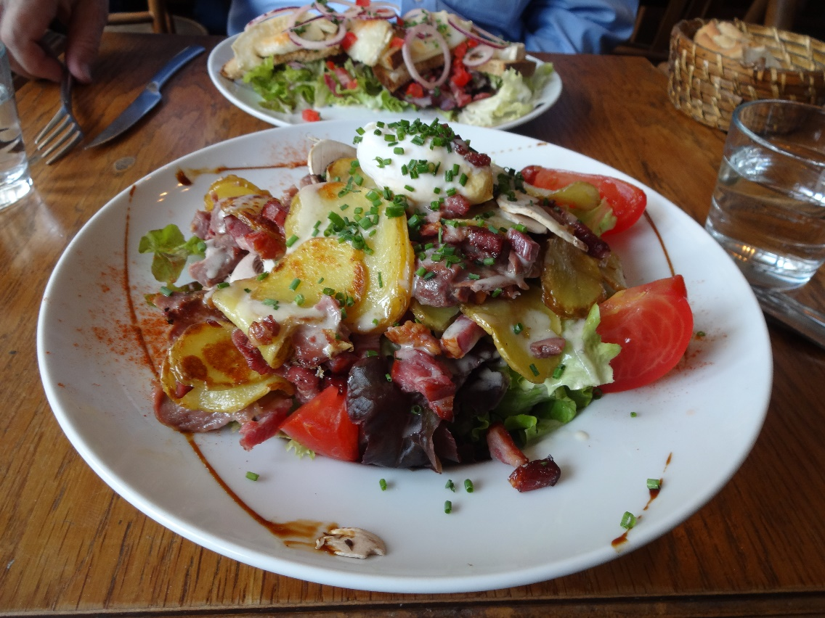When David appeared, we set off for the Bastille-Faubourg-Saint-Antoine bus stop, prospecting for lunch on the way. We settled at Le Préau, which turned out to be a very much local little place, where most of the customers seemed to know the proprietor. I had this perfectly lovely salad, which included lettuce, tomato, shaved raw mushrooms, fried potato slices, lardons, and confit chicken gizzards, all with a perfect poached egg balanced on top. That's David's salad with goat cheese grilled on toast and red onion rings in the background. For dessert, we split a pair of profiteroles with an outstanding hot chocolate sauce.

From the bus stop, the #86 bus took us, as promised, right to the Cluny despite some unnerving messages, on the display that should have been announcing the next stop, to the effect that because of roadwork, the route had been modified and it might not stop everywhere it normally would. No details provided about the modifications or what stops might be skipped!

As a result of major renovations, the museum had changed hugely, and for the better, since we were last there, decades ago.

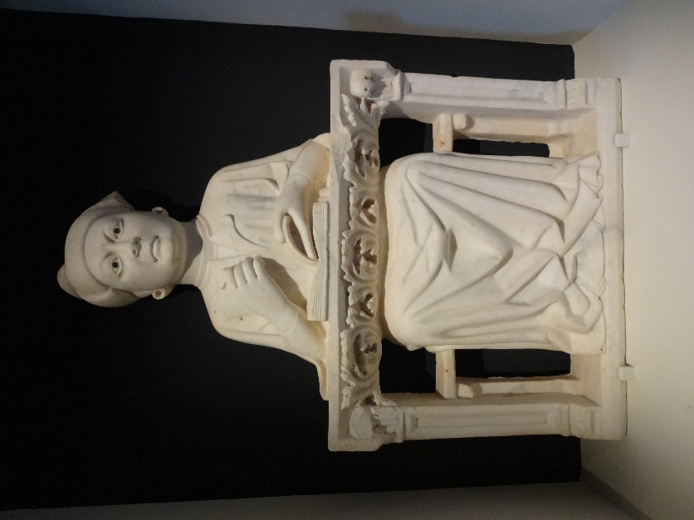David especially liked this 14th century appliquéd relief from the tomb marker of a university professor, shown sitting at his desk lecturing.

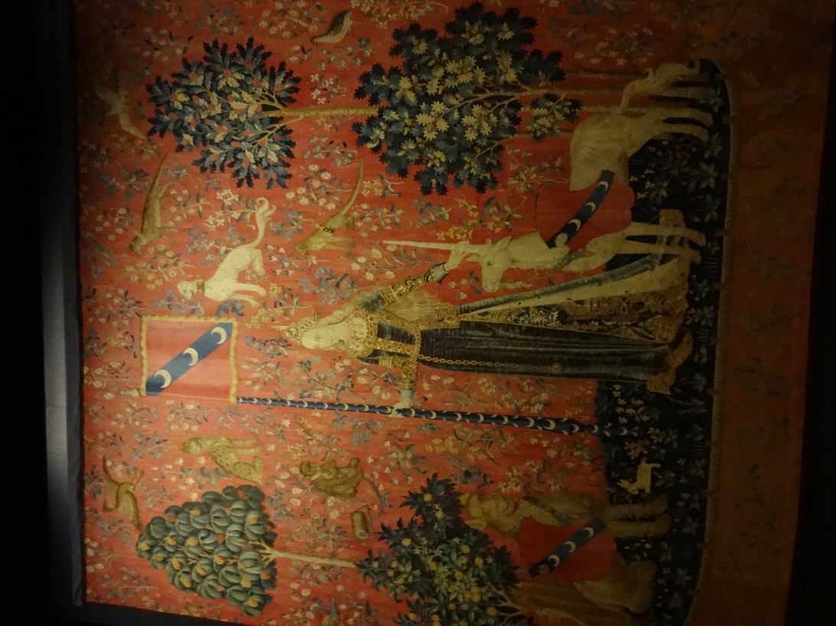

But what he had really come for were the unicorn tapestries.

Unfortunately, the museum was so short staffed that they could only really open one of its two floors at a time. Today, they started with the ground floor, which we hurried through before it was closed, but we were able to spend all the time we wanted on the upper floor, which was just opening up.

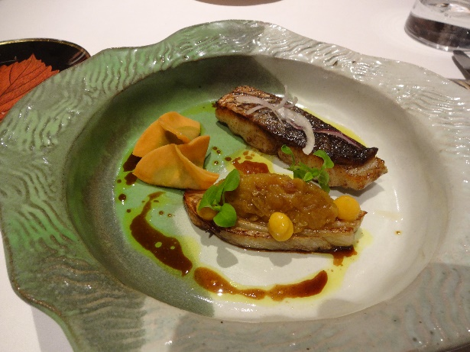We had dinner at Restaurant Jacques Faussat, where we had previously dined on 13 June 2019 (feel free to read all about it in my 2019 travel diary). This is our fish course: corvina accompanied by thin slices of sweet potato folded to contain a purée of green peas and a thick slice of fresh fennel grilled and topped with a quenelle of stewed eggplant (I think) and two splodges of a deliciously tart citrus purée. Wonderful!